Final Design Document

URL for my awesome term project: <http://youtu.be/BC0pGseXGTs>

Defining the Problem:

I would like to make the game Pac Man into a first-person view 3D game. To do this, I used Tkinter module for drawing. I have written my own Matrix, Vector and Point class to support calculations in the following diagram.

[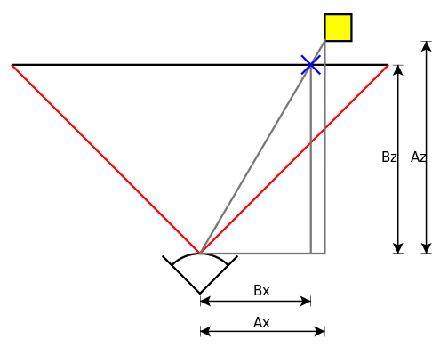](http://en.wikipedia.org/wiki/File:Perspective_transform_diagram.svg)

<http://en.wikipedia.org/wiki/3D_projection>

I would use the projection above to calculate the position (the method projection under PacMan class in main.py) of a point projected onto the screen, and draw polygons with these positions, creating a 3D effect.

Game Logic:

In addition to the 3D graphics. I have also written independent AIs for the ghosts chasing pac man. The red ghost would target the pac man directly while the blue and pink ghosts will try to cut the pac man off in according to its current direction. The orange ghost randomly decides to follow the pac man or move randomly in the game, adding randomness and playability to the game.

The board and the AI logic are adapted from the original pac man game.

<http://home.comcast.net/~jpittman2/pacman/pacmandossier.html>

User Interface:

Since I am making a 3D game, most of the information must be visualized so that the user can easily understand it while playing the game. Therefore, most of the information displayed on the interface is graphics rather than words. I have designed a mini-map to reduce the difficulty of navigating through the maze. I have also designed the walls to change colors when ghosts are around.

To enhance the visual effects, I have written the Color class to get gradually changing colors, which I applied to the 3 second count-down and the sky.

**User Study:**

Various use study cases pointed out that the most important need for the user is to visualize information, mainly focusing on 3 improvements:

1. Mini-map;

Users report that the first-person-view can be confusing for navigation. A mini-map would significantly reduce such confusion and add more control to game play.

1. Animated Tutorial:

Users also complain that without previous experience in 3D games like Counter Strike, it is difficult for them to get used to the keyboard-mouse control system of the gaming. Simply claiming that “Use A, S, D, W to move and mouse to rotate” is not enough. Therefore, I have made a step-by-step animated tutorial, explaining the user interface and game control to the user.

1. Buttons:

Since the user are enjoying the game with more visualization, I have changed most of the game-flow control to buttons instead of key presses. However, I have kept the r for restart and p for pause during game play because the interface is limited for a 3D first-person-view game.

Competitive Analysis (from competitive analysis and updated)

Before and while I am doing the projects, I have tried the following games from the internet.

1. 3D Maze

<http://www.youtube.com/watch?v=qBvZeIgAT3s>

The 3D maze is in the Gallery for previous term projects. It uses 3D projection to achieve 3D effects using 2D Tkinter. This 3D maze inspired me to do my term project, 3D Pac Man in Tkinter.

There are advantages and drawbacks in the 3D Maze:

1. The simplification is great. To reduce the stress on Tk, the student only draws nearby cells, a great idea which I will also implement in my project.
2. However, simply solving maze is not much fun. I have added 4 AIs to chase the user, making the game more intense and interesting.
3. 2.5D Pac Man

<http://www.youtube.com/watch?v=JwjbSdCns5g>

The video is a demo of a “fake” 3D Pac man. It uses 3D modules and is probably not written in Tkinter. The user cannot rotate or move the “camera”, but have a overall view of the whole board.

1. The 3D graphics and effects are great. The details of the 3D models are far better than Tkinter.
2. It is not real 3D, with the user hovering above the board. The game is not really different from the traditional 2D Pac Man
3. 2D classic Pac Man

<http://www.webpacman.com/>

The classic is the best!!! This is also the core of my game. It has a well-defined set of rules and AI logic.

1. Great rules and AI logic
2. It is not 3D.
3. 3D pac man from previous term projects:

<https://www.youtube.com/watch?v=nYECVvxc3d8>

Same problem with the 2.5D Pac Man. It is 3D but not first person view, which is not interesting. However, I must admit that VPython did a better job than the code I wrote myself.

Story Board: see Story Board (from story board and updated):

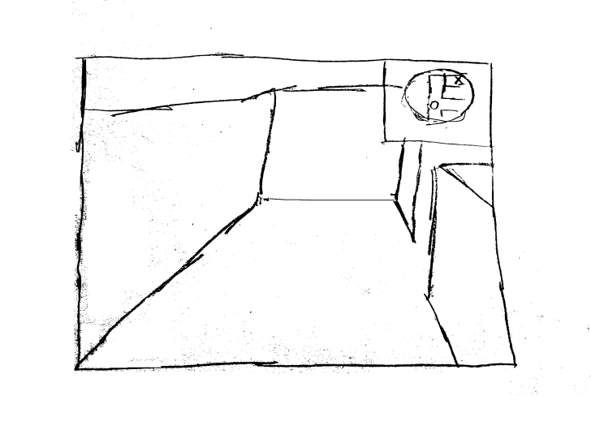

This is the basic 3D user interface.

The top right corner is a map, which is part of the 2D game board.

The middle of the screen is the user’s view.

Additional Features including lives, points will be added in the interface.

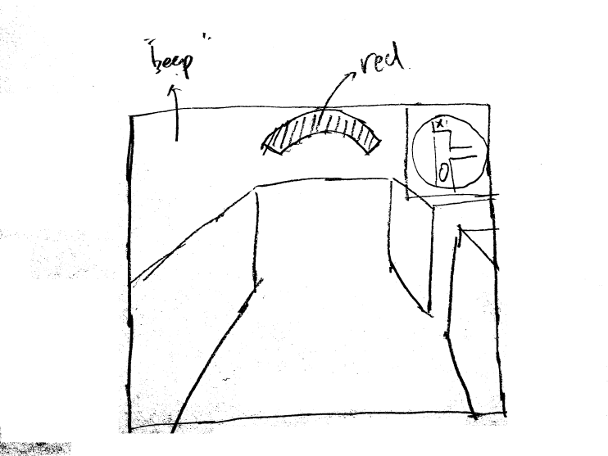The details will be described in the following pictures.

When a ghost is nearby, a red bar will be displayed on the screen, at the direction where the ghost is located. There will also be beeps as the ghost approaches the Pac man.

Below are the details of the user interface.

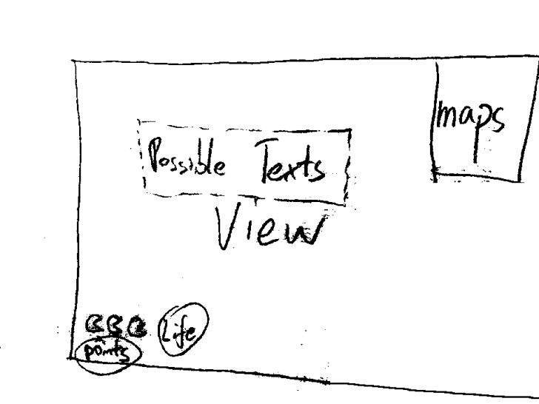Possible Texts: possible state hints (energized)

View: 3D view

Maps: 2D view

Life: Remaining lives

Points: Current Points